

Account switch & visitor pop-up
2024

Document version 0.01 – Apr 2024 (.fr version)

Pascal Vanhove
+32 2 662 1800

Tracking summary:

In v0.01 - approach

In this document:

This document is about opening a mobminder account from a third-party application, as well as passing an identifier allowing you to pre-open a visitor's file.

Context

Use on a computer using mouse, keyboard and web browser (Chrome, Safari, Firefox or Edge)
On the same computer a phone agent is used to take telephone calls.

This document therefore does not concern use on a Smartphone.

Functionalities

F01: When an operator takes a call, the calendar of the appropriate doctor opens up on their screen.

F02: When the calling number is recognized by Mobminder, the customer/patient file is preselected on the calendar.

Implementation options

In both cases, the phone agent calls and opens up the Mobminder calendar on a browser.

Method A : iFramed display in your telephony WebApp

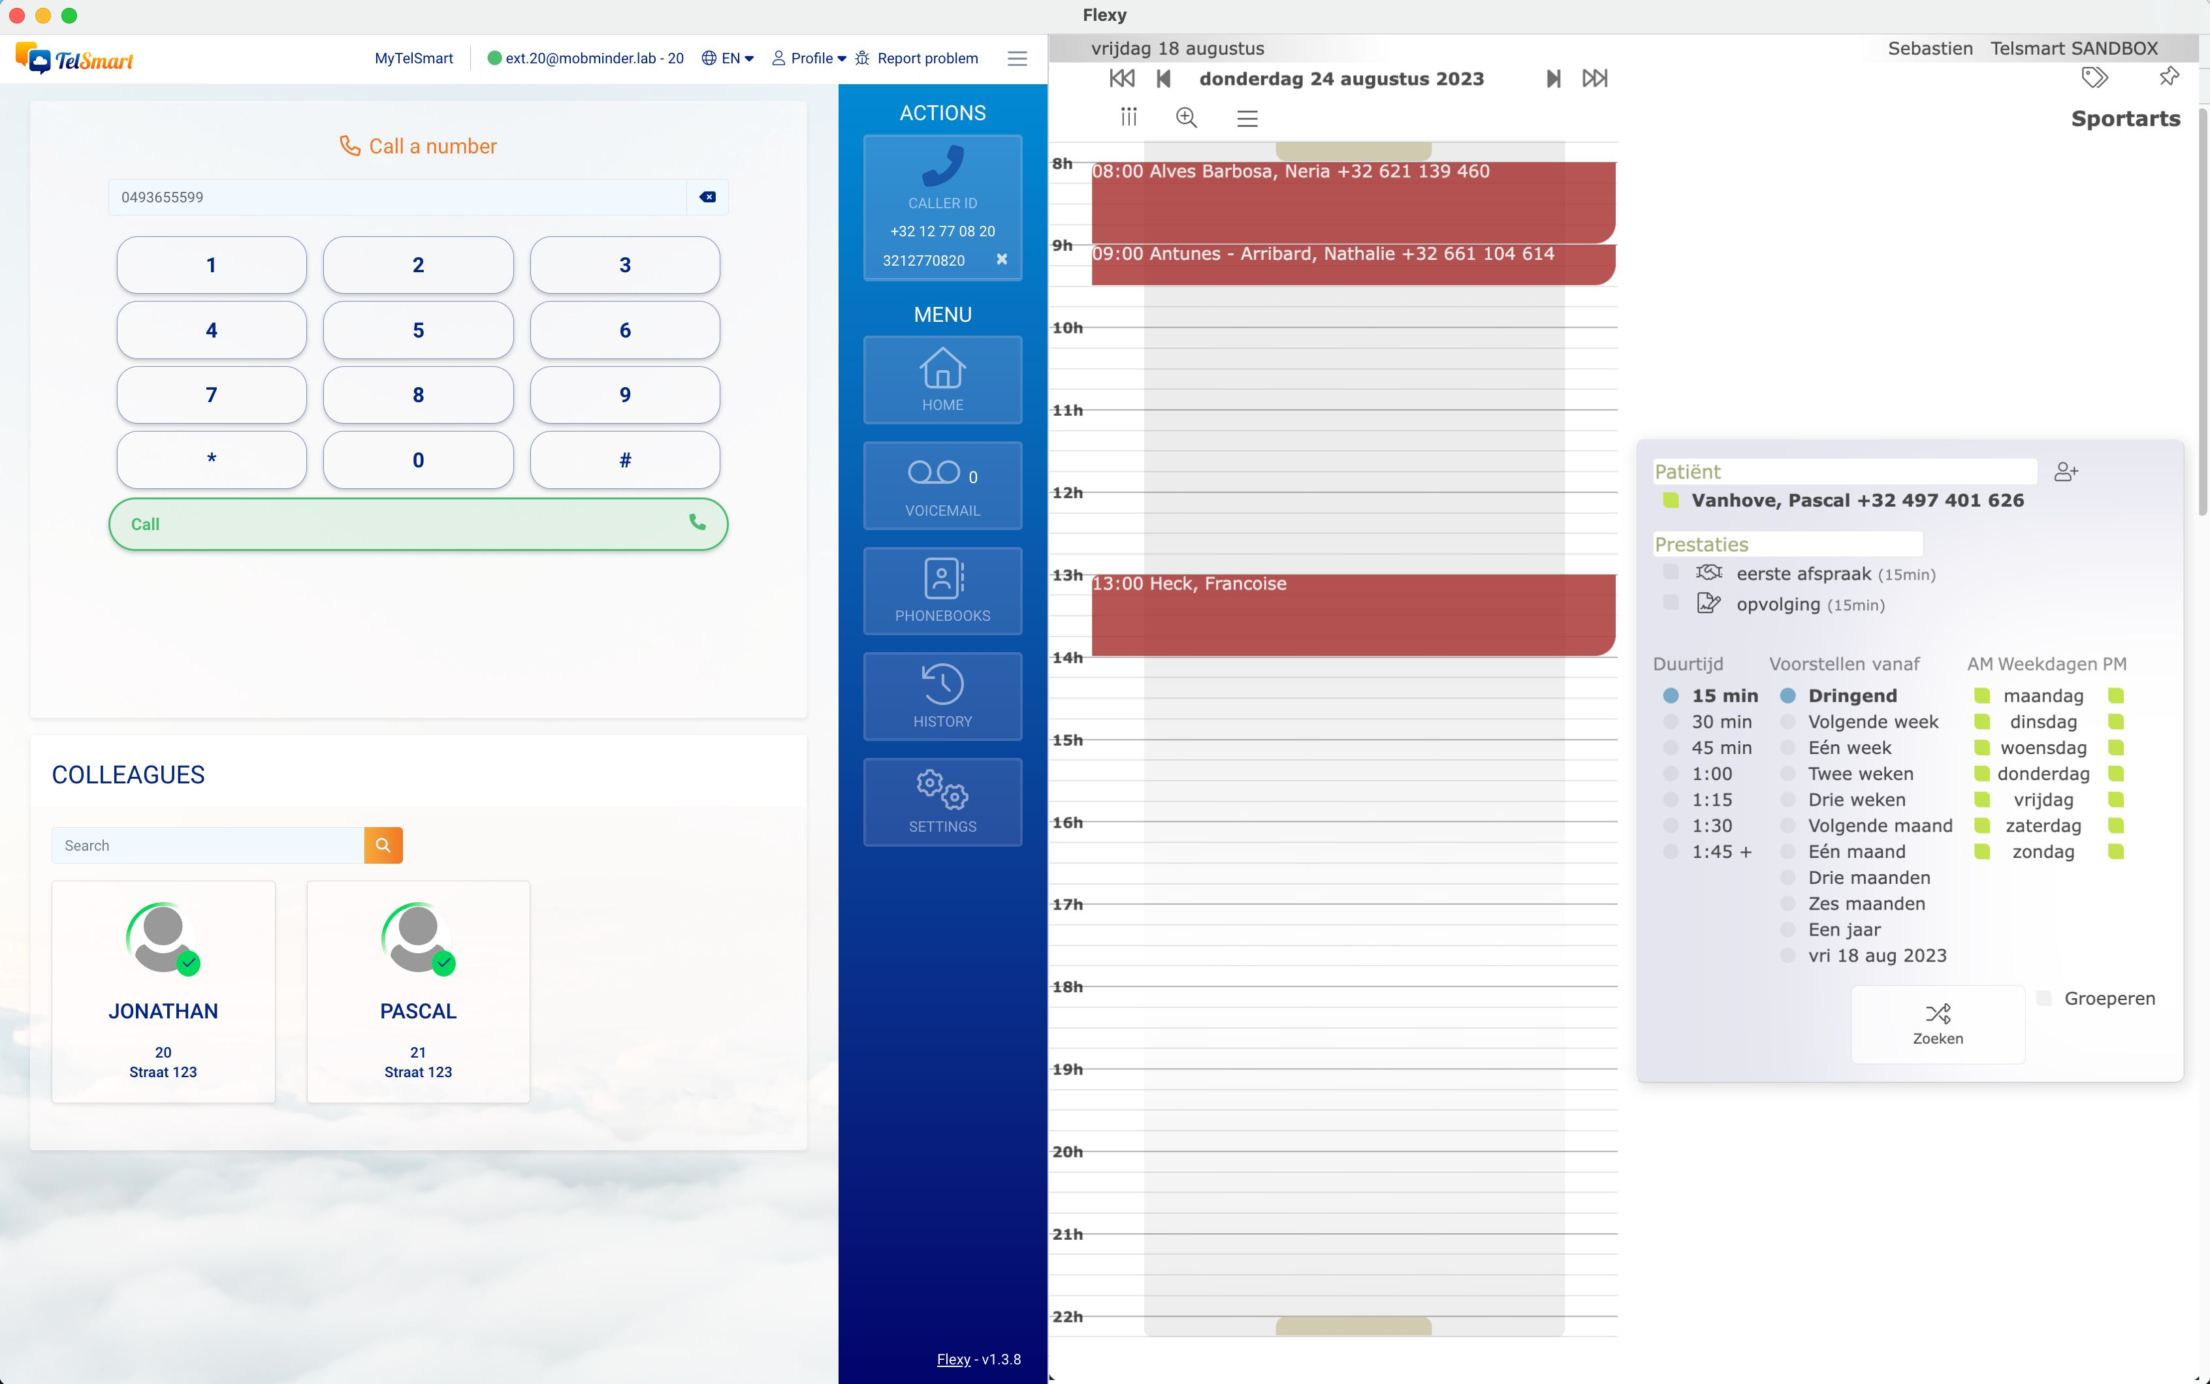

Method B : _target blank, opens a new tab in the browser

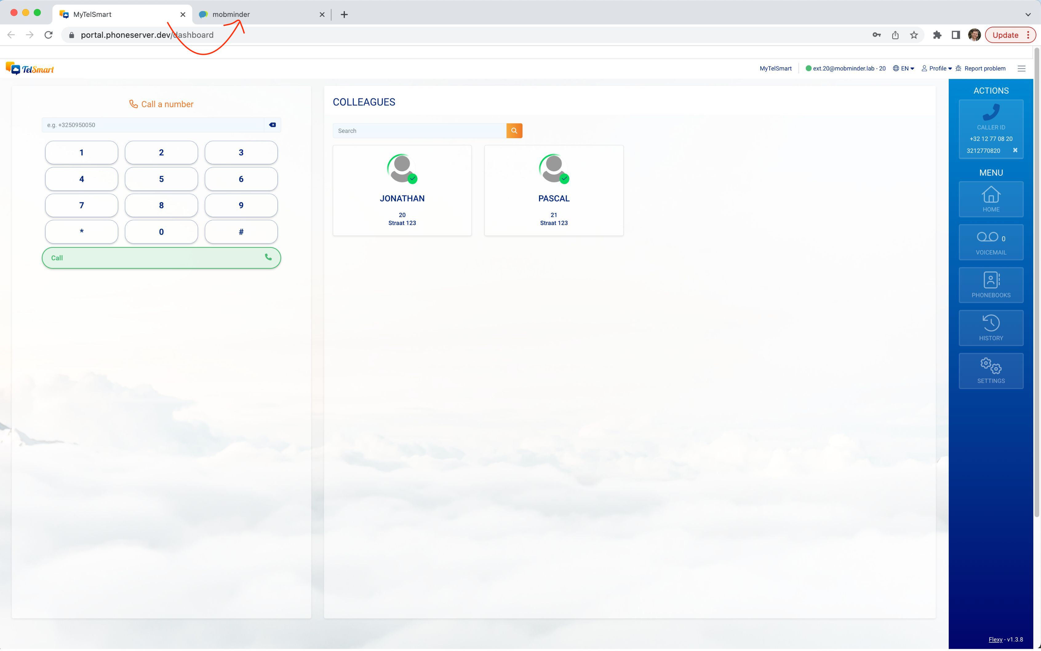

In both cases A or B, the operator is invited to enter his/her credentials on the first call.

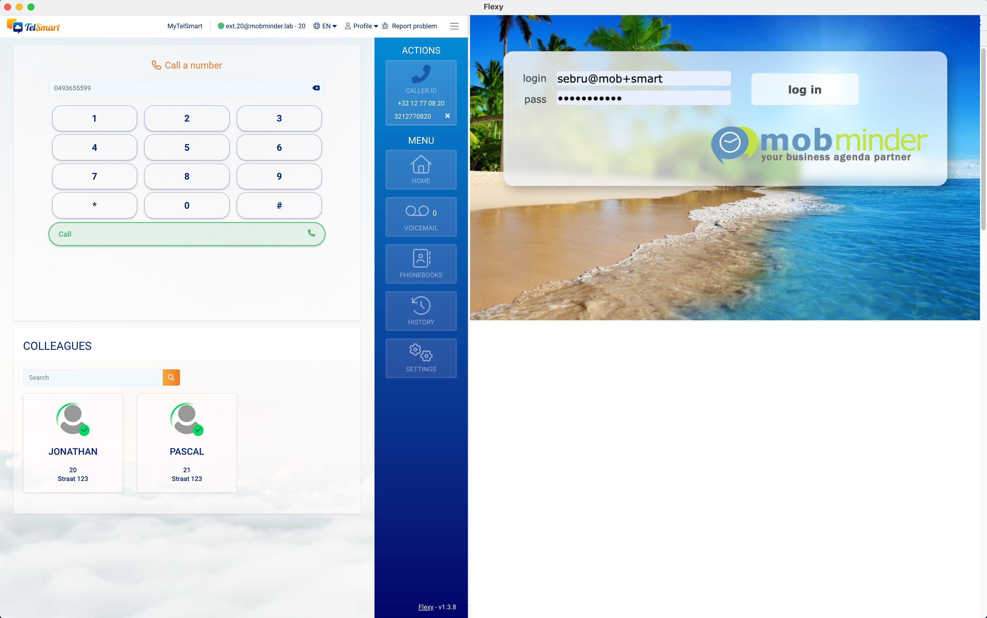

Get started

You need an access to a sandbox in Mobminder. You get those by separate email.

login : some login
pass : some password
url for our webapp : https://be.mobminder.com

Basics about using Mobminder agenda:

https://elearning.mobminder.com

Basics about the product:

https://www.mobminder.com

API

The correct URL for belgium is be.mobminder.com ? aid = AAAA & vgd = CC OOO 123456

Parameters passed are aid and vdg

aid stands for account id
vdg stands for visitor digits and is the caller id

account id:

Where AAAA is the mobminder account id ( numeric 4 digits )

Caller id :

Where CC is the country code according to standards

https://en.wikipedia.org/wiki/List_of_mobile_telephone_prefixes_by_country

Where OOO is the operator national prefix.
Where 123456 are national significative numbers (NSN, the amount of digits varies by country).

Mobile and fix numbers can be passed.

Example

be.mobminder.com ? aid = AAAA & vgd = 123456

Field examples

https://be.mobminder.com/index.php?aid=3566&vdg=0493401626

https://be.mobminder.com/index.php?aid=3566&vdg=32493401626

https://be.mobminder.com/index.php?aid=3566&vdg=+32497401626

https://be.mobminder.com/index.php?aid=3566&vdg=401626

Switch to another calendar :

https://be.mobminder.com/index.php?aid=3575&vdg=32475436876

